Enhanced stereochemistry example

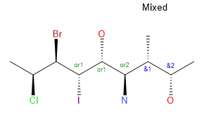
Structure with InChI numbering
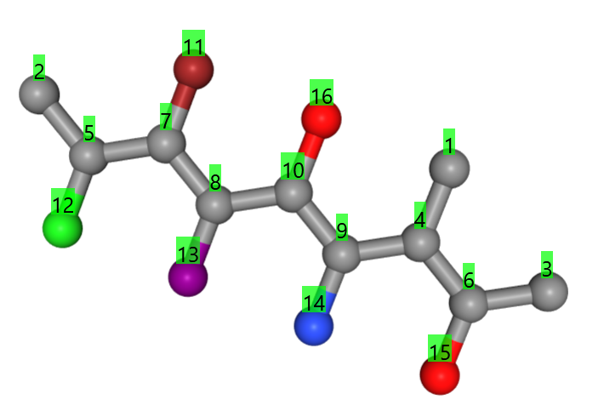

Standard InChI of version 1.07.5 (all centers are seen to be absolute)

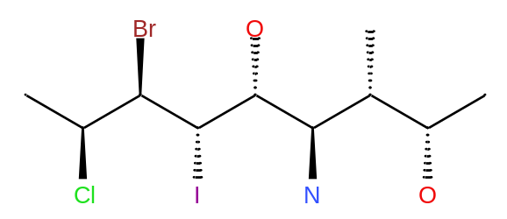
InChI=1S/C10H20BrClINO2/c1-4(6(3)15)9(14)10(16)8(13)7(11)5(2)12/h4-10,15-16H,14H2,1-3H3/t4-,5+,6+,7-,8-,9-,10+/m1/s1

Standard InChI of absolute centers
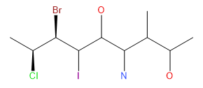
InChI=1S/C10H20BrClINO2/c1-4(6(3)15)9(14)10(16)8(13)7(11)5(2)12/h4-10,15-16H,14H2,1-3H3/t4?,5-,6?,7+,8?,9?,10?/m0/s1

Standard InChI for OR centers
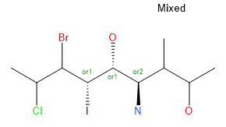
InChI=1S/C10H20BrClINO2/c1-4(6(3)15)9(14)10(16)8(13)7(11)5(2)12/h4-10,15-16H,14H2,1-3H3/t4?,5?,6?,7?,8-,9-,10+/m1/s1

Standard InChI for AND centers

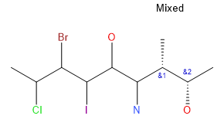
InChI=1S/C10H20BrClINO2/c1-4(6(3)15)9(14)10(16)8(13)7(11)5(2)12/h4-10,15-16H,14H2,1-3H3/t4-,5?,6+,7?,8?,9?,10?/m1/s1

Analysis of the tetrahedral stereo layer /t4-,5+,6+,7-,8-,9-,10+/m1/s1
Steps
- Group the tetrahedral centers according to their relationships in ABS, OR, and AND centers, order them ascendingly
  - The /m layer can only be related to the ABS centers
  - Example:
    - ABS section: /t5+,7-/m1
    - OR section: /t8-,9-,10+
    - AND section: /t4-6+
- Groups the centers according to the numbers of the OR and AND groups, each group is ordered ascendingly internally, the groups are ordered ascendingly to the first member of the groups- Each group is
  - ABS center can only be arranged into one group
  - Use /s1 for the ABS centers. /s2 for the OR (rel) centers, /s3 for the AND (rac) centers
  - Example:
    - ABS section: /t5+,7-/m1/s1(5,7)
    - OR section: /t8-,9-,10+/s2(8,10)(8)
    - AND section: /t4-6+/s3(4)(6)
  - Notes:
    - Groups may consist out of one member
    - In case you only have absolute centers the grouping is obsolete. The representation is reduced to /s1 and becomes identical to that one of SAbs
    - For OR and AND representations: in case there is only one OR or one AND group found in the structure (and none of the other types), the grouping is obsolete. The representation is reduced to /s2 for the OR case or /s3 for the AND case and becomes identical with the /SRel or /SRac InChI strings
- Each of the groups has to start with the #- representation with # as InChI atom number. In case it starts with #+ all signs of the group must be switched. Only for ABS centers /m0 must be exchanged against /m1 or vice versa.
  - Example:
    - ABS section: /t5+,7-/m1/s1(5,7)
      - It begins with + in /t5+,7-/m1 and must be switched to /t5-,7+/m0
    - OR section: /t8-,9-,10+/s2(8,10)(8)
      - No change, because the 2 groups begin with 8- and 9- respectively
    - AND section: /t4-6+/s3(4)(6)
      - Both of the atoms are independent of each other, i.e. you have 2 independent groups. The first atom of each group must start with “-“. In this case, 4- stays, but the parity of atom 6 must be turned to 6-.
    - Note : There is no /m layer available for the OR and AND groups. You have to chose the “-“ as starting point to ensure that the identification of the center becomes independent from the original drawing as stated in the documentation of OR and AND groups (see Biovia documentation “Chemical representation”).
- Rebuild the stereo layers /t /m /s
  - /t with increasing atom number and parity information
  - /m as taken from the analysis of the ABS centers.
    - Note: There are no /m information available for /s2 (OR) or /s3 (AND) centers. If you only have OR or AND centers the InChI cannot contain the /m layer-
  - Use /s to begin the stereolayer, use 1 (ABS), 2 (OR) , and 3 (AND) to indicate the stereochemistry type and add the group information for each type.
  - Example: /t4-,5-,6-,7+, t8-,9-,10+/m0/s1(5,7)2(8,10)(9)3(4)(6)
- Note: undefined stereocenters are not touched and keep their “?”
Section | Absolute | OR | AND
From SAbs string | /t5+,7-/m1/s1(5,7) | /t8-,9-,10+/s2(8,10)(9) | /t4-6+/s3(4)(6)
First center in a group must be negative, adapt /m for absolute centers | /t5-,7+/m0/s1(5,7) | /t8-,9-,10+/s2(8,10)(9) | /t4-6-/s3(4)(6)
Rebuild string | /t4-,5-,6-,7+, t8-,9-,10+/m0/s1(5,7)2(8,10)(9)3(4)(6)

Edge cases

Only ABS centers
The InChI of structures only containing ABS center must be identical to the current Standard-InChI. The identification of a compound must be independent of the molfile type (V2 or V3) that is used to represent the structure

Example
Structure | V2 Molfile | V3 Molfile | Expected InChI
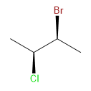 | ACCLDraw07032623592D  6 5 0 0 1 0 0 0 0 0999 V2000  4.3438 -4.4688 0.0000 C 0 0 1 0 0 0 0 0 0 0 0 0  5.3666 -3.8782 0.0000 C 0 0 1 0 0 0 0 0 0 0 0 0  4.3438 -5.6502 0.0000 Cl 0 0 0 0 0 0 0 0 0 0 0 0  3.3206 -3.8780 0.0000 C 0 0 0 0 0 0 0 0 0 0 0 0  5.3666 -2.6967 0.0000 Br 0 0 0 0 0 0 0 0 0 0 0 0  6.3898 -4.4689 0.0000 C 0 0 0 0 0 0 0 0 0 0 0 0  1 2 1 0 0 0 0  1 3 1 1 0 0 0  1 4 1 0 0 0 0  2 5 1 1 0 0 0  2 6 1 0 0 0 0  M END | ACCLDraw07042600032D  0 0 0 0 0 999 V3000  M V30 BEGIN CTAB  M V30 COUNTS 6 5 0 0 1  M V30 BEGIN ATOM  M V30 1 C 4.3438 -4.4688 0 0 CFG=1  M V30 2 C 5.3666 -3.8782 0 0 CFG=1  M V30 3 Cl 4.3438 -5.6502 0 0  M V30 4 C 3.3206 -3.878 0 0  M V30 5 Br 5.3666 -2.6967 0 0  M V30 6 C 6.3898 -4.4689 0 0  M V30 END ATOM  M V30 BEGIN BOND  M V30 1 1 1 2  M V30 2 1 1 3 CFG=1  M V30 3 1 1 4  M V30 4 1 2 5 CFG=1  M V30 5 1 2 6  M V30 END BOND  M V30 BEGIN COLLECTION  M V30 MDLV30/STEABS ATOMS=(2 1 2)  M V30 END COLLECTION  M V30 END CTAB  M END | InChI=1S/C4H8BrCl/c1-3(5)4(2)6/h3-4H,1-2H3/t3-,4-/m0/s1

Only 1 OR# center type, e.g. OR1
The InChI of structures containing only one OR# type must be identical to the InChI calculated with /SRel. That means, that only /s2 as stereo layer is used while the /m layer is obsolete in this case.
Structure | V2 Molfile | V3 Molfile | Expected InChI
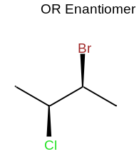 |  | ACCLDraw07042600062D  0 0 0 0 0 999 V3000  M V30 BEGIN CTAB  M V30 COUNTS 6 5 0 0 0  M V30 BEGIN ATOM  M V30 1 C 4.1136 -10.2015 0 0 CFG=1  M V30 2 C 5.1364 -9.611 0 0 CFG=1  M V30 3 Cl 4.1136 -11.383 0 0  M V30 4 C 3.0904 -9.6108 0 0  M V30 5 Br 5.1364 -8.4295 0 0  M V30 6 C 6.1596 -10.2017 0 0  M V30 END ATOM  M V30 BEGIN BOND  M V30 1 1 1 2  M V30 2 1 1 3 CFG=1  M V30 3 1 1 4  M V30 4 1 2 5 CFG=1  M V30 5 1 2 6  M V30 END BOND  M V30 BEGIN COLLECTION  M V30 MDLV30/STEREL1 ATOMS=(2 1 2)  M V30 END COLLECTION  M V30 END CTAB  M END | InChI=1S/C4H8BrCl/c1-3(5)4(2)6/h3-4H,1-2H3/t3-,4-/s2

Only one AND# center type, e.g. AND1
The InChI of structures containing only one AND# type must be identical to the InChI calculated with /SRAC. That means, that only /s3 as stereo layer is used while the /m layer is obsolete.

Structure | V2 Molfile | V3 Molfile | Expected InChI
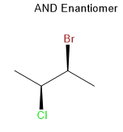 |  | ACCLDraw07042600072D  0 0 0 0 0 999 V3000  M V30 BEGIN CTAB  M V30 COUNTS 6 5 0 0 0  M V30 BEGIN ATOM  M V30 1 C 4.4573 -15.7953 0 0 CFG=1  M V30 2 C 5.4802 -15.2047 0 0 CFG=1  M V30 3 Cl 4.4573 -16.9767 0 0  M V30 4 C 3.4341 -15.2045 0 0  M V30 5 Br 5.4802 -14.0233 0 0  M V30 6 C 6.5034 -15.7955 0 0  M V30 END ATOM  M V30 BEGIN BOND  M V30 1 1 1 2  M V30 2 1 1 3 CFG=1  M V30 3 1 1 4  M V30 4 1 2 5 CFG=1  M V30 5 1 2 6  M V30 END BOND  M V30 BEGIN COLLECTION  M V30 MDLV30/STERAC1 ATOMS=(2 1 2)  M V30 END COLLECTION  M V30 END CTAB  M END | InChI=1S/C4H8BrCl/c1-3(5)4(2)6/h3-4H,1-2H3/t3-,4-/s3

